 | SURVITEC ZODIAC LIFERAFT TEST AND SURVEY REPORT n° |  |  |  |  |  |  |  |  |  |  | PAGE No 1/3
 | Date: _ _/_ _/ _ _ |  | Station N°: _ _ _ _ _ |  | REINSPECTION CERTIFICATE N°: _ _ _ _ _ _
 | Type of liferaft |  |  |  |  | Ship name
 | Capacity |  |  |  |  | Owner
 | Serial n° |  |  |  |  | Flag state
 | Pack |  |  |  |  | IMO N°
 | Date of Manufacture |  |  |  |  | Last service
 | Painter Line length |  |  |  |  | By station n°
 | Stowage height |  |  |  |  | Last certificate n°
 |  | Information if MES SIS raft (mini slide) |  |  |  |  |  | Left |  |  |  | Right
 |  |  |  | Position of container on board |  |  | Port side |  |  |  | Starboard
 |  |  |  | Firing Line Length (if EBL)
 |  |  | Mooring springs position for SIS slide connection |  |  |  | 1 | 2 | 3 | 4 |  | 5 | 6

  - BLAST TEST on inflation hoses

- OVERPRESSURE VALVES *
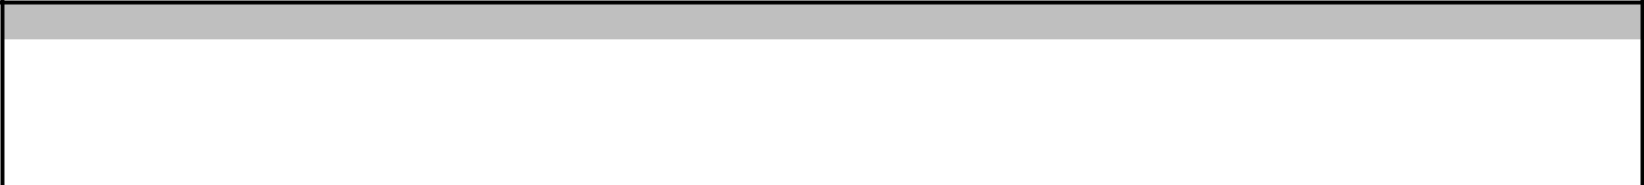
Start: |  |  | TUBES |  |  |  |  |  | ARCHES
End: | UP / F1 | LOW / F2 | F3 | F4 | F5 | F6 | A1 | A2 | A3 | A4 | A5 | A6
Opening
Reset

- Opening/reset pressures of the over pressure valves according to the color of the dot on the valve. Refer to Manual MS003, page 4 in PART I - Controls, Solas Tests

LIFERAFT FITTED WITH VENTURI: VENTURI PROTECTIVE TUBE

Overpressure valves test UPPER LOWER

Opening (max 296)

Reset (mini 206)
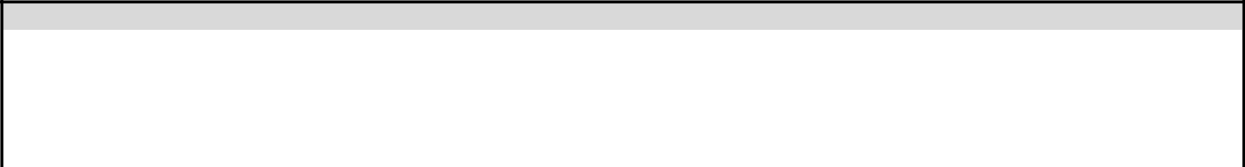

3. WORKING PRESSURE TEST (WP test) Tolerance 5% of start pressure
 |  |  |  |  |  |  | Time |  |  |  |  |  | Temperature |  |  |  |  | Atmospheric pressure
 |  |  | Start |  |  |  |  |  |  |  |  | T1: |  |  |  |  | P1:
 |  |  | End |  |  |  |  |  |  |  |  | T2: |  |  |  |  | P2:
 |  |  |  | Difference
 |  |  |  | Correction
 |  |  |  |  | TUBES |  |  |  |  |  |  |  |  |  |  | ARCHES
 |  |  | UP / F1 | LOW / F2 |  | F3 | F4 |  | F5 |  | F6 |  | A1 | A2 |  | A3 |  | A4 |  | A5 | A6
 | Start
 | End
 | Result (after
 | correction)
 | Valid test
 | YES/NO
 |  |  | LIFERAFT FITTED WITH VENTURI: VENTURI PROTECTIVE TUBE
 |  |  | Pressure Test |  |  |  | Time |  |  |  | UP (~235 mbar) |  |  |  | LOW (~235 mbar)
 |  |  | Start
 |  |  | End (test on 10 mn)
 |  |  | Final Result (OK if loss < 130 mbar)

Ed.03-2020
SURVITEC ZODIAC LIFERAFT TEST AND SURVEY REPORT n° PAGE No 2/3
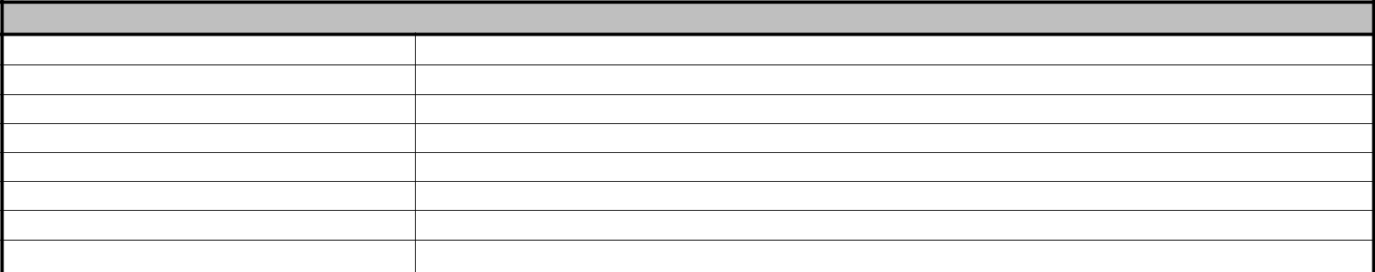

- CYLINDERS

Cylinder N° CO2 Weight N2 Weight

Full Weight

Weight reading

Last Hydro test

Cylinder refilling date

Firing head Type & n°

 | 5. TESTS CARRIED OUT | Yes | No

NAP TEST

GI test

Floor seam test

Over load test (DL)

Cylinder hydro test

Hoses replaced

 | 6. LIFERAFT INSPECTION
 | Main buoyancies | Check |  | R* |  |  | Canopy |  |  |  |  | Check |  | R* | Inner floor |  | Check |  |  | R*
 | Buoyancy |  |  |  | Canopy |  |  |  |  |  |  |  |  |  | Automatic bailer
 | Reflective tape |  |  |  | Reflective tape |  |  |  |  |  |  |  |  |  | Vacuum breaker
 | Outer lifeline |  |  |  | Rainwater collector |  |  |  |  |  |  |  |  |  | Insulating foam/rem. floor
 | Inner lifeline |  |  |  | Entrances |  |  |  |  |  |  |  |  |  | Outer floor |  | Check |  |  | R*
 | Painter patch |  |  |  | External flashing light |  |  |  |  |  |  |  |  |  | Reflective tape
 | Towing patch |  |  |  | Arches |  |  |  |  |  |  |  |  |  | Water pockets
 | Bowsing lines |  |  |  | Shackle / Ring (DL) |  |  |  |  |  |  |  |  |  | CO² cyl. pocket/Velcro straps
 | Ramp / Ladder |  |  |  | Webbings (DL) |  |  |  |  |  |  |  |  |  | Righting straps
 | Overpressure valves
 | Overpressure valves caps |  |  |  |  | Container / Valise |  |  |  |  |  | Check |  | R* | Inflation system |  | Check |  |  | R*
 | Labels |  |  |  | Upper shell |  |  |  |  |  |  |  |  |  | CO² valves
 | Floating knife |  |  |  | Lower shell |  |  |  |  |  |  |  |  |  | Hoses
 | Sea Anchor |  |  |  | Foam / plastic sheet |  |  |  |  |  |  |  |  |  | Inflation valves
 | Quoit + Line |  |  |  | Painter line
 | Painter line retrieving line |  |  |  | Labels |  |  |  |  |  |  |  |  |  | If raft fitted with Venturi |  | Check |  |  | R*
 | Signal card |  |  |  | Identification tube |  |  |  |  |  |  |  |  |  | Venturi
 | Immediate actions card |  |  |  | Shackle access cover (DL) |  |  |  |  |  |  |  |  |  | Venturi caps
 | Lighting system |  |  |  |  |  |  |  |  |  |  |  |  |  | Venturi flap cover
 | R* = replacement
 | 7. IF MES LIFERAFT: CONNECTION LINES
 |  |  |  |  |  | MES SIS LIFERAFT (Mini slide)
 | Extremity Bowsing Line (EBL) |  |  |  |  |  | Check |  |  | R* |  | Central Bowsing Line (CBL) |  |  |  |  | Check |  |  | R*
 | EBL system good condition (Bowsing lines + Shock |  |  |  |  |  |  |  |  |  | CBL system good condition (Shock absorber +
 | absorbers) |  |  |  |  |  |  |  |  |  | Safety line)
 | Bowsing lines attached with 35kg zip ties |  |  |  |  |  |  |  |  |  | 4 rings (per side) connected
 | 2 B. lines with connected shock absorber (one per side) |  |  |  |  |  |  |  |  |  | Shackles secured
 | Slings connected to the EBL system |  |  |  |  |  |  |  |  |  | Bowsing line + Painter connected to the CBL system
 |  |  |  |  | MES MIS LIFERAFT (Super slide)
 | PRIMARY |  |  |  |  |  | Check |  |  | R* |  | SECONDARY / ADDITIONNAL |  |  |  |  | Check |  |  | R*
 | Blue Tether line attached with 9 kg (x2) zip ties |  |  |  |  |  |  |  |  |  | Extremity connection lines fixed with 9 kg (x2) zip ties
 | Bowsing lines V connected with shackle + secured |  |  |  |  |  |  |  |  |  | Short connection lines OR shackles connected (in
 |  |  |  |  |  |  |  |  |  |  | vacuum pouch)
 | Slings connected to the Bowsing V |  |  |  |  |  |  |  |  |  | Pre-connection lines connected (out of vacuum pouch)
Ed.03-2020

SURVITEC ZODIAC LIFERAFT TEST AND SURVEY REPORT n° PAGE No 3/3

8. ACCESSORIES INSPECTION

Equipment | Check | R* | Expiry date
In the pack:
Hand flares
Rocket parachute
Smoke signal
Food
Water
First aid kit
Seasickness tablets
Batteries 1,5V
Glue in repair kit
EPIRB
Outside of the pack:
Radar transponder
HRU
Lighting system
(battery + flashing light)
R* = replacement
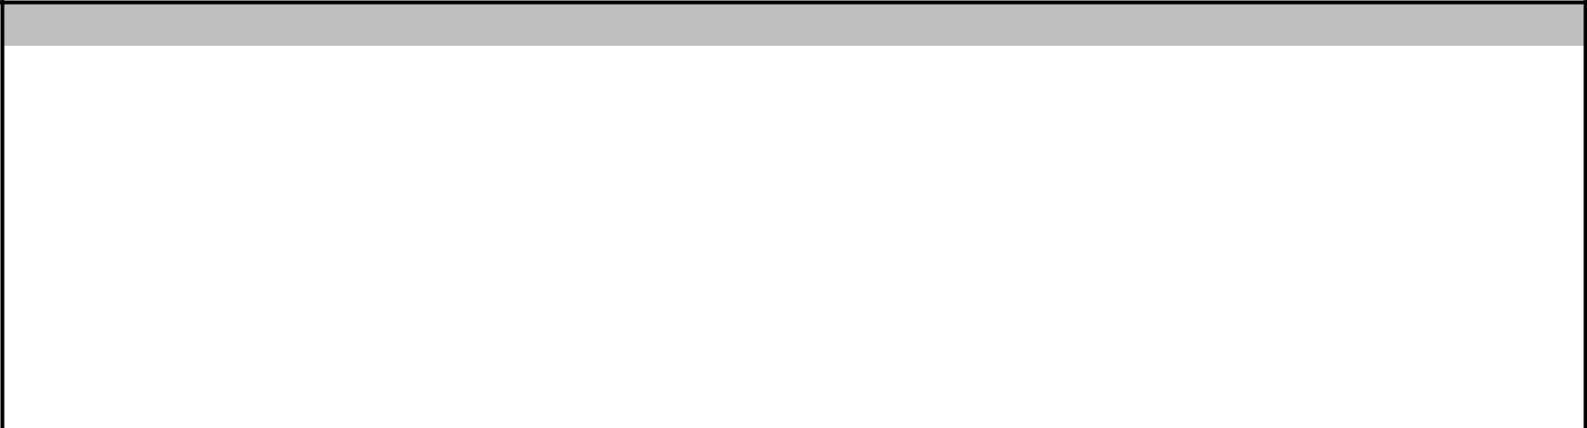

Other equipment | Check | R*

Leak stopper

Foot pump

Bailer

Sponge

Tin opener

Fishing kit

Torch

Spare bulb

Signal mirror

Whistle

Drinking vessel

Seasickness bags

Sea anchor

Paddles

Rainwater collector

Servicing history

T.P.A.

Radar reflector

9. LIFERAFT AND EQUIPMENT CONDITION INFORMATION

 |  |  |  |  | Yes | No |  | Yes | No
 | Was the raft wet? |  |  |  |  |  | Was the liferaft damaged?
 | Was the container damaged? |  |  |  |  |  | Had the liferaft been fired
 | Nature and extent of the damages:
 | Nature and extent of the defects:
 | Repairs carried out / remarks:

10. REPACKING WITH SAFETY CHECK - PACKER / CHECKER

 | DOCUMENTS |  | Packer | Checker
 | Liferaft label completed
 | ID card completed
 | Re-inspection certificate completed

DOCUMENTS | Packer | Checker
Container label completed
Servicing history completed

 | CONNECTIONS |  | Packer | Checker.
 | Light connected
 | Painter line connected
 | Quick firing line connected
 | DL container: shackle access cover
 | glued

For liferaft with VENTURI | Packer | Checker
Venturi flap cover in position
Venturi caps removed
Venturis opened / secured
Venturi protection rolled
Venturi protection held in central
pos. on container (Not on MIS R302)

Station n°: | Technician’s name: | Signature:
 | Checker’s name: | Signature:
IMPORTANT - The « Technician or Packer » as well as the « Checker » must be approved by SurvitecZodiac.
Please contact SurvitecZodiac for approval if an exemption is needed.

- The fields « Packer » and « Checker » must be always filled with the initials or with « N/A».

Ed.03-2020

